This resource is designed to identify sensory preferences. Once identified these care be shared with others to enhance experiences.
Sensory Preferences
Includes a Sensory Passport
Michele Stevenson Advanced Specialist Occupational Therapist Devon Adult Autism Intervention Team (DAAIT) (DEVON PARTNERSHIP NHS TRUST)

Your Sensory Preferences
By using the following sensory checklists, you can gain insight into your sensory preferences and better understand the types of sensory input that bring you comfort and regulation. These checklists can serve as a starting point for creating a sensory-friendly environment that supports your individual needs.
The following sensory preference checklist serves as a tool to support your sensory journey, providing insights into the experiences that nourish and resonate with you. It can be a starting point for creating your personalised sensory diet and cultivating an environment that caters to your sensory well-being.
The resource has an explanation of each of the environments you are likely to experience broken down into separate elements. Some of this may be a new understanding to yourself, additionally, you may have other elements you would like to add. Following this, there is a checklist where you can tick the elements. You may wish to share this with family, friends, work or others so that they can understand how environments impact on you.

Sensory Preference Checklist: Lighting
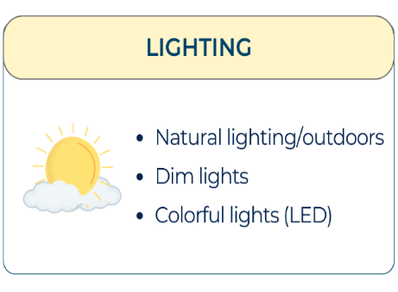
Natural lighting: The warm glow of natural sunlight can have a calming and uplifting effect. Being in spaces with ample natural light may enhance your mood and overall sensory experience.  Difficulties may include the changeable nature of natural light. | Dim lighting: Soft, low-level lighting can create a cosy and relaxing atmosphere. It can help reduce sensory overload and create a sense of calm. | Bright lighting: Bright, well-lit environments can promote alertness and focus. Some individuals may find bright lighting energising and beneficial for certain activities.  Difficulties may include light flickering, different intensities of bulbs, inability to tone it down.
Artificial light: Standard indoor lighting, such as fluorescent or incandescent bulbs, provides consistent and reliable illumination. It is commonly found in most indoor environments.  Difficulties: See bright lighting | Colourful lighting (LED): LED lights come in various colours and can create a vibrant and visually stimulating atmosphere. Colourful lighting options allow you to customise the ambience to suit your sensory preferences. | Moderate lighting: Moderate lighting strikes a balance between bright and dim, providing sufficient illumination without being too overwhelming. It can offer a comfortable environment for various activities.
Yellow hues (warm lighting): Warm, yellow-toned lighting can create a cosy and inviting atmosphere. It can contribute to a sense of relaxation and comfort. | Cool spectrum light (white): Cool spectrum or white light tends to have a brighter and more energising effect. It can mimic natural daylight and may promote focus and productivity. | Other: Identify any additional visual preferences or experiences that resonate with you personally.
When considering your sensory preferences for lighting, take note of how different lighting conditions make you feel.
- Do you prefer the warm and soothing glow of natural sunlight or the cosy ambiance of dim lighting?
- Are you drawn to colourful lighting that sparks joy and visual interest?
- Can you tolerate some light for longer than others?
- Are some specific colours problematic?
Reflect on your responses and identify the lighting options that align with your sensory preferences. Also, note how your preferences may change depending on your activity (if you are studying vs. socialising vs. resting, for example). By understanding and incorporating your sensory preferences for lighting, you can create visually appealing, calming spaces conducive to your overall sensory preferences

Sensory Preference Checklist: Visual
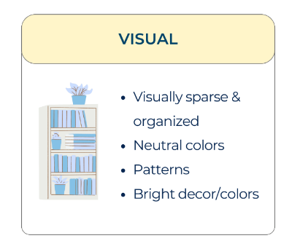
Visually sparse & organised: Some individuals find comfort and clarity in a visually minimalist and organised environment with minimal distractions. | Neutral colours: A preference for neutral colour palettes, such as shades of white, beige, or grey, can create a calming and soothing visual atmosphere. | Vibrant colours: Others may enjoy the energy and stimulation provided by vibrant and bold colours in their surroundings.
Patterns and bright decor: Patterns, intricate designs, and visually stimulating decorations can be appealing to individuals who enjoy visual variety and stimulation. | Solid colours: A preference for solid colours, without complex patterns or designs, can create a visually calming and harmonious environment.  Some colours may be more challenging than others. | Minimalism: Embracing a minimalist visual aesthetic with clean lines and uncluttered spaces can provide a sense of serenity and simplicity.
Everything spread out/visible: Having a preference for visual accessibility and being able to see everything in one's environment can contribute to a sense of control and reduced anxiety. | No preference: Some individuals may not have a strong preference for specific visual elements and feel comfortable in a variety of visual environments. | Other: Identify any additional visual preferences or experiences that resonate with you personally.
Consider the visual elements that bring you a sense of comfort, focus, or inspiration. Reflect on the colours, patterns, organisation, or openness that enhance your visual experience. Tailor your surroundings to align with your preferences and create a visually supportive environment that promotes your well-being.

Sensory Preference Checklist: Tactile
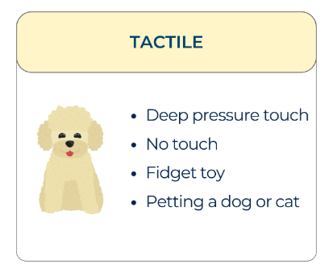

Light touch: Some individuals may enjoy gentle, feather-like touches on their skin. Light touch can provide a soothing and comforting sensation. | Deep pressure touch: Firm and deep pressure can be grounding and calming for many individuals. Activities such as hugging, squeezing, or using weighted blankets can provide deep pressure stimulation. | No touch: Some individuals may prefer minimal tactile stimulation and feel more comfortable without physical contact.
Pet a dog or cat: Interacting with pets, such as stroking or petting a dog or cat, can offer tactile comfort and a sense of connection. | Warm bath or shower: The sensation of warm water can be soothing and relaxing. Taking a warm bath or shower can provide tactile and sensory enjoyment. However, it can also be uncomfortable and people can struggle with the changes in temperature, feel of the water, and smell of products during the process of washing.  Water can either bring solace or discomfort. Does it for you? | Rub or pick at clothes: Some individuals may engage in rubbing or picking at their clothes as a way to self-soothe or regulate sensory input.  Sometimes people also pick at their skin and this can cause discomfort.
Twirling hair: Twirling or playing with hair can be a self-soothing behaviour for many individuals. The repetitive motion can provide sensory comfort. |  | Receive a massage: Massage therapy can provide a combination of deep pressure touch and relaxation, promoting sensory regulation and stress reduction.
Soft textures: Exploring fabrics or materials with a soft and plush texture can be comforting and enjoyable.  Jersey, fleece or velvet might be included. | Smooth textures: Smooth surfaces or objects can offer a pleasing tactile experience for those who appreciate sensory input. | Preferences for specific fabrics: Some individuals may have preferences for certain types of fabrics, such as silky, fuzzy, or textured materials.
Fidget toy: Fidget toys, such as stress balls or textured objects, can offer tactile stimulation and help individuals regulate their sensory experiences. | Consider the tactile sensations that bring you comfort and joy. Reflect on the activities or textures that make you feel calm, grounded, or stimulated in a positive way. Everyone's tactile preferences are unique, so take the time to explore and discover what works best for you. Incorporate these preferences into your sensory experiences and create a sensory-friendly environment that supports your well-being.
Other: Identify any additional visual preferences or experiences that resonate with you personally

Sensory Preference Checklist: Sound
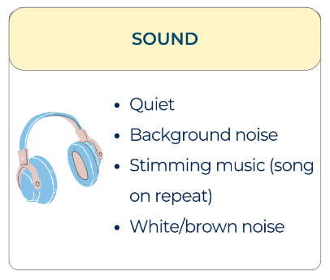

Quiet: Some individuals prefer a quiet environment, free from excessive noise or distractions. They find peace and focus in a calm and serene auditory atmosphere. | White Noise/Brown Noise: Background noise, such as white noise or brown noise, can be soothing and help individuals concentrate or relax. It masks other sounds and provides a constant and consistent auditory input. | Loud and lively: Certain individuals thrive in an environment with energetic and vibrant sounds. They enjoy the buzz and excitement of a lively atmosphere.
Music/Background noise: Having music or background noise, such as ambient sounds or soft music, can be pleasing and provide a comforting backdrop to their activities. | Television on in the background: Some individuals find comfort in having the television on as background noise, creating a sense of familiarity and cosiness. | No preference: Some individuals may not have specific preferences for auditory stimuli and feel comfortable in various sound environments.
Other: Identify any additional auditory preferences or experiences that resonate with you personally. | Consider your auditory preferences and how different sound environments impact your well-being. Whether it's finding solace in silence, embracing the presence of background noise, or seeking out specific types of sounds for relaxation or stimulation, honour and create an auditory environment that aligns with your preferences.

Sensory Preference Checklist: Taste
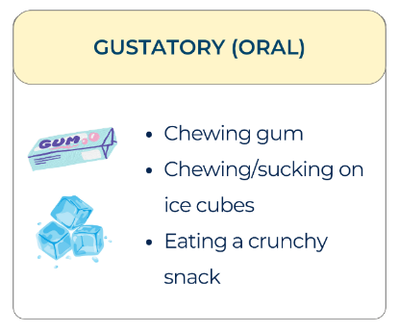

Chewing gum: Some individuals find chewing gum to be satisfying and helpful for sensory regulation. | Crunchy snacks: Enjoying crunchy snacks provides a sensory experience and can contribute to a sense of satisfaction and stimulation. | Chewing on items: Chewing on straws or similar objects may provide oral sensory input and a soothing effect for some individuals.
Suck, lip, or bite lips or cheeks: Some individuals engage in oral habits like sucking, biting, or pressing lips or cheeks for sensory stimulation and comfort. | Chewing on ice: Chewing on ice can provide a cooling, refreshing, and grounding sensory experience for some people. | Spicy food: The sensation of spicy flavours can be stimulating and enjoyable for those who have a preference for spicy food or are sensory seeking.
Drink a warm beverage: Drinking a warm beverage, such as tea or coffee, can provide a soothing and calming sensation. | Drink a carbonated drink: The effervescence and bubbles of carbonated drinks can provide a unique sensory experience and is great for sensory seekers. | Other: Identify any additional gustatory preferences or experiences that resonate with you personally.
Be mindful of your gustatory preferences and explore different tastes and textures that bring you comfort and satisfaction. Consider incorporating sensory-friendly foods and beverages into your daily routines to enhance your sensory well-being

Sensory Preference Checklist: Smell
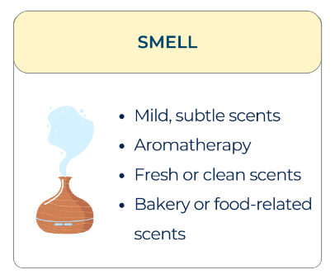

Mild or subtle scents: Preference for gentle or delicate fragrances that are not overpowering. | Fresh or clean smells: Enjoyment of scents associated with cleanliness, such as fresh laundry or a clean breeze. | Citrus or fruity scents: Pleasure derived from the aroma of citrus fruits or other fruity fragrances.
Bakery or food-related scents: Appreciation for scents reminiscent of baked goods, cooking, or specific food items. | Herbal or earthy scents: Fondness for scents derived from herbs, plants, or natural earthy aromas. | Aromatherapy scents (e.g., lavender, eucalyptus): Preference for scents commonly used in aromatherapy for relaxation or invigoration.
Natural scents (e.g., flowers, trees): Enjoyment of the fragrances found in nature, such as floral scents or the smell of trees. | Specific scents that bring joyful memories: Identification of particular scents that evoke positive memories or feelings of joy. | Other: Recognition of any additional olfactory preferences or experiences that resonate with you personally.
Consider the scents that bring you comfort, relaxation, or a sense of joy. Explore the variety of fragrances available and identify those that align with your olfactory (smell) preferences. Incorporate scents into your environment that promote a sensory experience that supports your well-being.

Sensory Preference Checklist: Proprioception

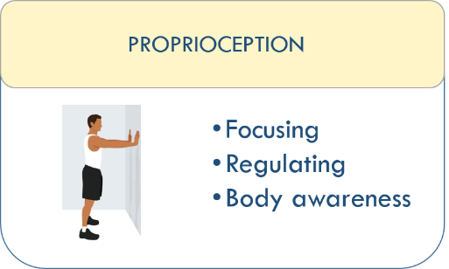
Lift weights: Engaging in weightlifting or resistance training exercises can provide deep pressure and sensory input, promoting a sense of body awareness and regulation. | Pressure: Seeking out activities or items that apply pressure to the body, such as firm hugs, compression garments, or weighted items, can provide a grounding and calming effect. | Weighted equipment: Appreciating the sensation of additional weight or pressure on the body, whether through weighted clothing, weighted blankets, or carrying heavy objects, can offer a sense of stability and comfort.
Pillow/weighted blanket: Finding comfort and relaxation by using pillows or weighted blankets, which provide a gentle, even pressure sensation, promoting a sense of security and calm. | No pressure (avoidance): Avoiding or feeling discomfort with activities or items that apply pressure or weight to the body, preferring lighter touch or gentle movements instead. | Other: Identify any additional proprioceptive preferences or experiences that resonate with you personally.
Understanding your proprioceptive preferences can help you create an environment that supports your sensory well-being. Whether it's engaging in weightlifting exercises, seeking pressure or weight sensations, or opting for a lighter touch, embrace the activities and items that bring you comfort and regulate your proprioceptive system.

Sensory Preference Checklist: Movement
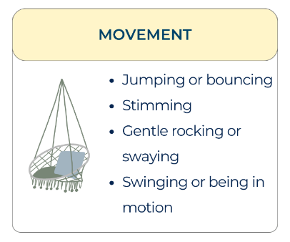

Rocking: Finding comfort and sensory regulation through rhythmic rocking movements, which can provide a soothing and grounding effect. | Rock in a rocking chair: Seeking the repetitive back-and-forth motion of a rocking chair, which can promote relaxation and sensory regulation. | Swaying: Engaging in gentle swaying movements, whether self-initiated or through the use of a swing or hammock, to promote a sense of calm and sensory integration.
Riding a bike: Finding enjoyment and sensory regulation through cycling or bike riding, which can provide a combination of physical activity and rhythmic movement. | Being still: Preferring minimal movement and maintaining a relatively static posture, finding sensory comfort in stillness. | Other: Identify any additional movement preferences or considerations that resonate with you personally.
Recognising and incorporating movement preferences can play a significant role in supporting sensory regulation and overall well-being. Explore different movement options and activities that align with your sensory needs, providing comfort, relaxation, and sensory integration opportunities.

Sensory Preference Checklist: Environment
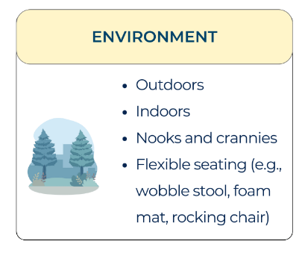

Outdoors: Being in an outdoor environment, surrounded by nature and fresh air, can be invigorating and calming for some individuals. | Indoors: Finding comfort and security in indoor environments, where one can control the sensory elements, can provide a sense of stability and relaxation. | Outside and covered: Enjoying the outdoors while having the option of finding shelter or shade can provide a balanced sensory experience for those who prefer a mix of indoor and outdoor elements.
Nooks and crannies: Seeking out cosy and secluded spaces, such as small corners or tucked-away areas, can offer a sense of security and a calming environment. | Open space: Feeling at ease in open and expansive environments, where there is ample room to move and breathe, can provide a sense of freedom and sensory satisfaction. | No preference: Having no specific preference for a particular environment, being adaptable to different surroundings, or finding comfort in a variety of settings.
Other: Identify any additional environmental preferences or experiences that resonate with you personally. | Pay attention to your surroundings and create an environment that aligns with your sensory preferences. Whether it's finding solace in the tranquillity of nature or seeking comfort in a cosy nook, your environment can play a significant role in your sensory well-being.

Sensory Preference Checklist: Temperature
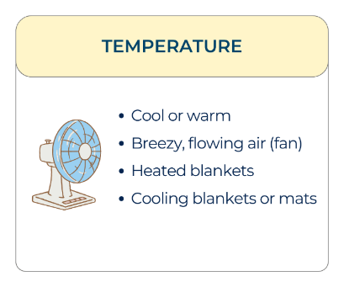

Cool: Finding comfort and sensory regulation in cooler temperatures or environments, can help in reducing sensory overwhelm and promoting a sense of calmness. | Warm: Seeking warmth and cosiness, finding sensory comfort in warmer temperatures, or using warm materials such as blankets or heated pads for relaxation. | Breeze/airflow: Enjoy gentle air movement or breezes, whether through open windows, fans, or outdoor environments, to promote a sense of freshness and sensory soothing.
Neutral Temperature: Preferring a temperature that is neither too hot nor too cold, finding sensory comfort in a balanced and moderate environment. | No preference: Not having a specific temperature preference, feeling comfortable in various temperature ranges. | Other: Specify any additional temperature preferences or considerations that resonate with you personally.)
Understanding and attending to temperature preferences can contribute to creating a more comfortable and supportive sensory environment. Adjusting the temperature settings, using appropriate clothing, and considering personal temperature preferences can promote optimal sensory well-being and regulation

Sensory Preference Checklist: Clothing
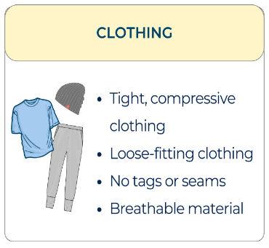

Constriction clothing (tight): Finding comfort and sensory regulation through wearing clothing that provides a snug or tight fit, creating a sense of grounding and security. | Loose-fitting clothing: Preferring clothing that allows for freedom of movement and minimal restriction, providing a sense of ease and comfort. | Cotton fabric: Enjoying the softness and breathability of cotton fabric, which can be gentle on the skin and help regulate body temperature.
Tagless clothing: Seeking clothing without tags or labels that can cause discomfort or irritation against the skin. | Seamless garments: Choosing clothing items that are seamless, reducing the potential for sensory irritation and providing a smooth, comfortable experience. | Compression garments: Finding relief and sensory regulation through the use of compression clothing, which applies gentle pressure to the body.
Breathable materials (e.g., bamboo, linen): Opting for fabrics that promote airflow and ventilation, enhancing comfort and preventing overheating. | Soft and gentle textures (e.g., velour, fleece): Preferring clothing with soft and cosy textures that provide a soothing sensory experience. | Non-irritating fabrics (e.g., organic cotton, modal): Selecting fabrics that are hypoallergenic and less likely to cause skin irritation or discomfort.
Adjustable closures (e.g., Velcro, snaps): Choosing clothing with adjustable closures to customise the fit and avoid sensory discomfort from tight or restrictive closures. | Stretchy and flexible clothing: Embracing clothing that offers stretch and flexibility, allowing for ease of movement and accommodating sensory sensitivities. | Weighted or pressure-based clothing: Seeking the comforting sensation of weighted or pressure-based clothing items that provide gentle, constant pressure on the body.
Moisture-wicking fabrics: Opt for fabrics that draw moisture away from the skin, keeping you dry and comfortable, especially during physical activities. | Non-restrictive waistbands (e.g., elastic-free): Preferring waistbands that are not constricting or elastic, providing a more comfortable and sensory-friendly fit. | Layering options for temperature regulation: Choosing clothing that allows for layering, providing flexibility to adjust to different temperatures and sensory needs.
Odour-resistant or hypoallergenic materials: Selecting clothing made from materials that resist odour or are hypoallergenic, reducing sensory discomfort and irritation. | Other: (Identify any additional clothing preferences or considerations that resonate with you personally.) | Understanding your clothing preferences can help create a sensory-friendly wardrobe that supports your comfort and well-being. Whether it's the choice of fabric, fit, or closure, prioritise clothing options that align with your sensory needs and enhance your overall sensory experience.

Sensory Preference Checklist: People

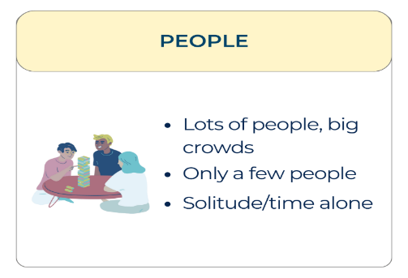
Lots of people: Some individuals thrive in social environments with large crowds and enjoy the energy and buzz of being around many people. | People who you don't know: Interacting with unfamiliar people or strangers may be exciting and stimulating for individuals who enjoy meeting new individuals and exploring new social connections. | Only a few people: Others prefer smaller social gatherings or interactions with a limited number of individuals, finding comfort and ease in more intimate settings.
A small group of people: Some individuals feel most comfortable and engaged in small group settings where they can actively participate and connect with others. | Alone: Enjoying solitude and time spent alone is a preference for individuals who find solace, recharge, and rejuvenation in their own company. | Other: Identify any additional preferences or experiences related to being around people that resonate with you personally.
Consider your social preferences and the types of social interactions that bring you joy, comfort, and fulfilment. Whether it's thriving in a crowd, cherishing one-on-one connections, finding solace in solitude, or embracing the excitement of meeting new people, honour and create opportunities for social experiences that align with your preferences

Exploring Your Sensory Preferences
Exploring your sensory profile and identifying your sensory preferences is an ongoing and personalised journey. Here are some additional strategies to help you in this exploration:
- Reflect and self-observe: Take time to reflect on your sensory experiences throughout the day. Pay attention to how different sensory inputs affect your mood, energy levels, and overall well-being. Notice what feels calming, overwhelming, or stimulating to your senses.
- Experiment with different environments: Create opportunities to experience different sensory environments. Visit different places, such as parks, libraries, or coffee shops, and observe how the sensory elements in each setting impact your comfort level and sensory experience.
- Engage in sensory activities: Try out various sensory activities to discover what resonates with you. Experiment with different textures, sounds, tastes, and movements. Engaging in activities like listening to soothing music, engaging in art or crafts, or spending time in nature can help you identify your sensory preferences.
- Seek input from others: Engage in conversations with trusted friends, family members, or therapists about your sensory experiences. Their observations and insights can provide valuable perspectives and help you gain a deeper understanding of your sensory preferences.
The aim is to develop a better understanding of your own sensory landscape and create a sensory-friendly environment that supports your well-being. By embracing the journey of self-discovery, you will continue to explore and refine your understanding of your sensory profile over time.
Please make your choices on the following checklist so that others may better understand how to adapt an environment to meet your needs. Or, if adaptations are unable to be made to allow others to understand how this might impact on your ability to manage in that environment.

Sensory Choices Passport
This sensory passport identifies my preferred choices and is intended to support me in enhancing my experiences so that I can be at my best.
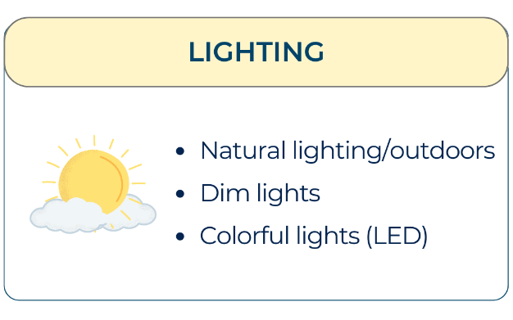 | ☐ Natural lighting  ☐ Dim lighting  ☐ Bright lighting  ☐ Artificial light  ☐ Colourful lighting (LED)  ☐ Moderate lighting  ☐ Yellow hues (warm lighting)  ☐ Cool spectrum light (white) | ☐ Other: Please add.
 | ☐ Visually sparse & organised  ☐ Neutral colours  ☐ Vibrant colours  ☐ Patterns and bright décor  ☐ Solid colours  ☐ Minimalism  ☐ Everything spread out/visible  ☐ Familiar objects  ☐ No preference | ☐ Other: Please add.
 | ☐ Light touch  ☐ Deep pressure touch  ☐ No touch  ☐ Twirling hair  ☐ Fidget toy  ☐ Receive a massage  ☐ Pet a dog or cat  ☐ Warm bath or shower  ☐ Rub or pick at clothes  ☐ Soft textures  ☐ Smooth textures | ☐ Other: Please add.
 | ☐ Quiet  ☐ White Noise/Brown Noise  ☐ Loud and lively  ☐ Music/Background noise  ☐ Television on in the background  ☐ No preference | ☐ Other: Please add.
 | ☐ Chewing gum  ☐ Crunchy snacks  ☐ Chewing on straws  ☐ Suck, lip, or bite lips or cheeks  ☐ Chewing on ice  ☐ Spicy food  ☐ Drink a warm beverage  ☐ Drink a carbonated drink | ☐ Other: Please add.
 | ☐ Mild or subtle scents  ☐ Fresh or clean smells  ☐ Citrus or fruity scents  ☐ Bakery or food-related scents  ☐ Herbal or earthy scents  ☐ Aromatherapy scents (e.g., lavender, eucalyptus)  ☐ Natural scents (e.g., flowers, trees)  ☐ Specific scents that bring joyful memories | ☐ Other: Please add.
 | ☐ Rocking  ☐ Rock in a rocking chair  ☐ Swaying  ☐ Riding a bike  ☐ Being still | ☐ Other: Please add.
 | ☐ Outdoors  ☐ Indoors  ☐ Outside and covered  ☐ No preference  ☐ Open space  ☐ Nooks and crannies | ☐ Other: Please add.
 | ☐ Cool  ☐ Warm  ☐ Breeze/airflow  ☐ No preference  ☐ Neutral Temperature | ☐ Other: Please add.
 | ☐ Moisture-wicking fabrics  ☐ Weighted or pressure-based clothing  ☐ Stretchy and flexible clothing  ☐ Adjustable closures  ☐ Non-irritating fabrics  ☐ Soft and gentle textures  ☐ Breathable materials  ☐ Tagless clothing  ☐ Seamless garments  ☐ Compression garments  ☐ Cotton fabric  ☐ Loose-fitting clothing  ☐ Constriction clothing (tight)  ☐ Odour-resistant or hypoallergenic materials  ☐ Layering options for temperature regulation | ☐ Other: Please add.
 | ☐ A small group of people  ☐ Only people you know  ☐ Alone  ☐ Only a few people  ☐ People who you don't know  ☐ Lots of people | ☐ Other: Please add.
Anything else you would like to share with others so they can ensure your needs are met please add here. For instance, this can include timings for meetings (e.g. am or pm), rooms or buildings that are preferred, set up of the meeting space, and how information is shared with you.

